## Darshan Nikam Date: 21/02/2024

**Task 1)** How to set Multi-factor authentication (MFA) for AWS user

Use of MFA to increase the security of your AWS environment. Signing in with MFA requires an authentication code from an MFA device. Each user can have a maximum of 8 MFA devices assigned.

To set MFA follow the following steps (Using Authenticator App)

1. You need to download the Google Authenticator App or Microsoft Authenticator App
2. Sign in to the AWS Management Console
3. Go to IAM Service, you can simply search IAM or click on the Account info button and select Security Credentials.

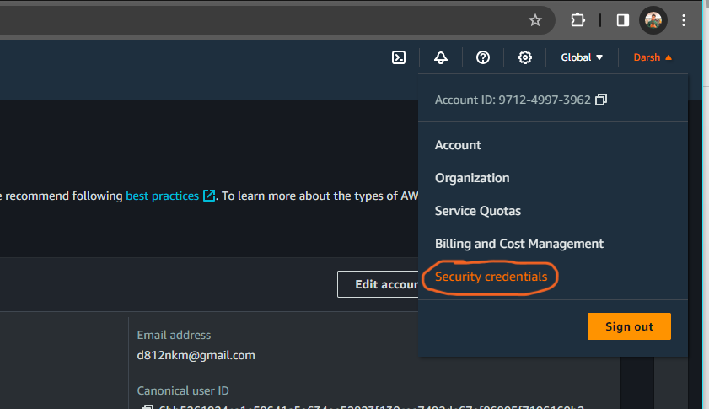

1. Give Your Device name and select the Authenticator app option then click on the next button.

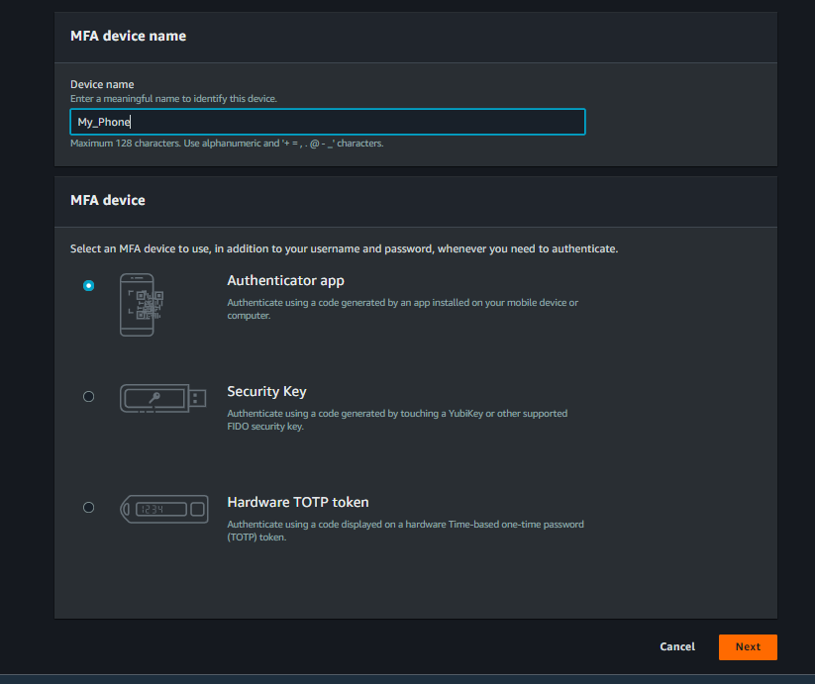

1. Click on Show QR Code, then scan the QR code on the Authenticator App.
2. After Scanning QR you will get a secret MFA code in your Authenticator App, enter the code

and click on the Add MFA Button.

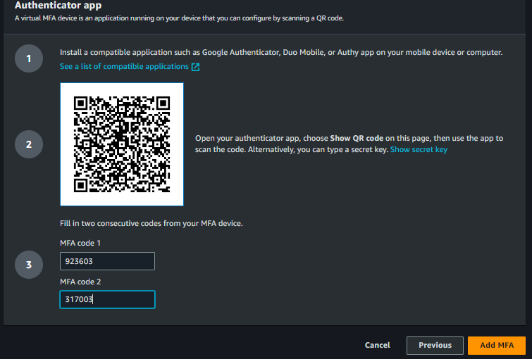

Now you will see MFA is enabled in your AWS account.

Note: To Set MFA for a Particular user Go to IAM service, select user, click on Security Credentials, then assign MFA.

**Task 2) Set a Custom Password Policy for Users.**

1. Sign in to the AWS Management Console
2. Go to IAM Service, you can simply search IAM, or directly search Account settings.

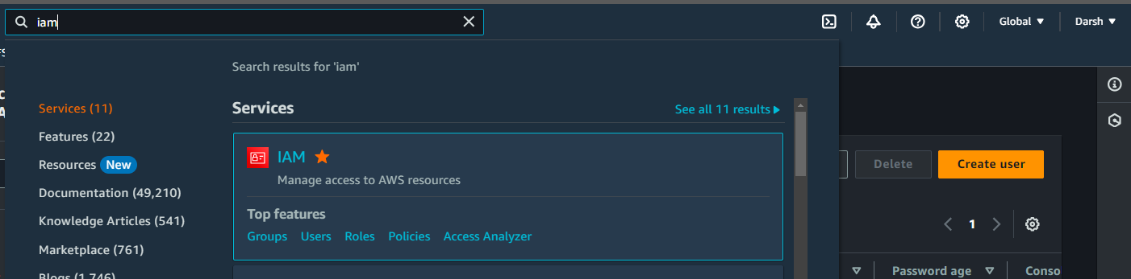

1. Look at the IAM dashboard Access Management Menu and click on Account Settings.

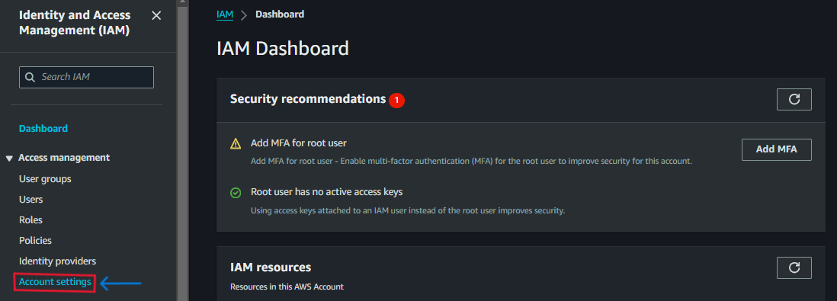

1. Click on the edit button of the Password policy.

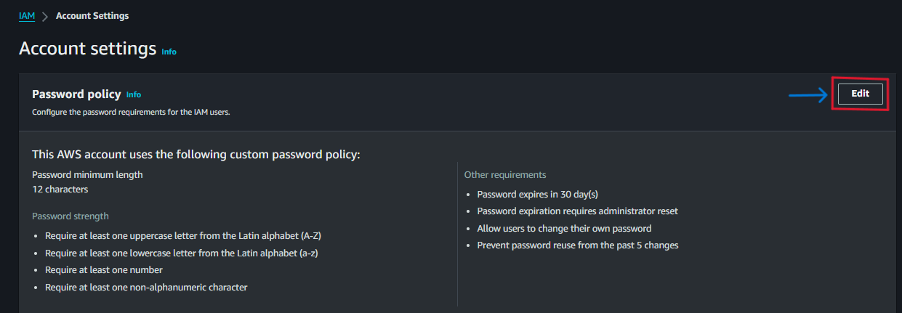

1. Select the Custom option, set the Password policy as your requirement, and simply click on Save Changes.

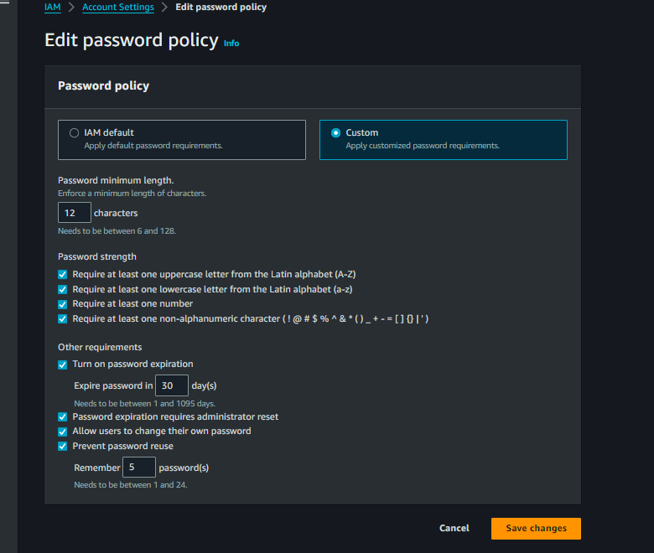

Note: This policy will impact any new user creation and all the existing users changing their passwords.

**Task 3) Create an IAM User in an AWS Account.**

Follow the following steps to create an IAM user in AWS

1. Sign in to the AWS Management Console
2. Go to IAM Service, you can simply search IAM and click on it. (Also user option appears in drop up box, simply click on the user)



1. Then click on the Create User button and specify the user details like user name, user access, and console password and check or uncheck box to the create a new password in the first login or not. After that click on the next button.

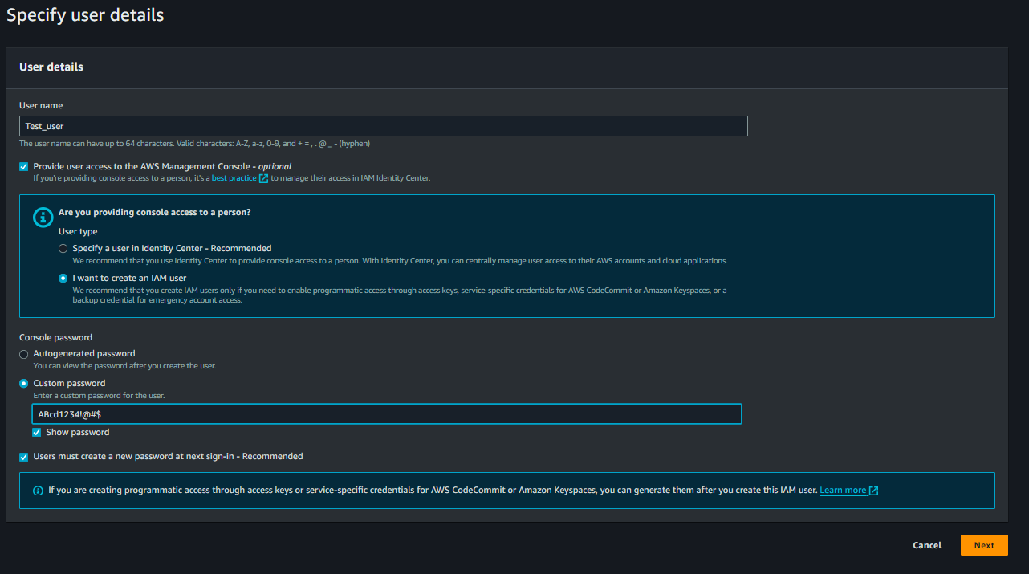

1. Select the Permission Group that you want to give to the user or create a new Group permission, and also have the option to select existing user permissions groups and policies that you can select.

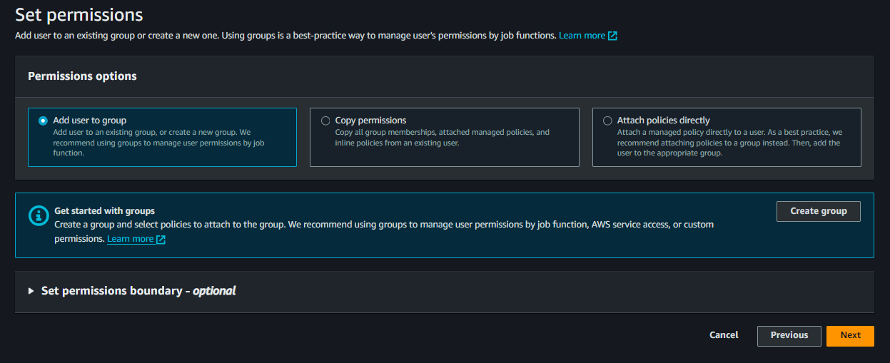

1. After selecting Permission click on the Next Button, Review and Create page will open, carefully check the all details after creating the user, and then add a tag for the user (Optional) use of a tag is to identify the user.

Then simply click on the Create User Button and download your user Password file.

Now you will see the user has been created.